08-04-2019
Normal Takeoff & Climb
Flaps = 10º
Check approach for traffic
Taxi onto runway, lineup with centerline
Use proper control inputs for wind conditions
Verify runway # with heading indicator
Smooth and continuous application of full throttle
Callout: Instruments in the green
Airspeed alive
Rotate
Rotate at 55 kts
Attitude – 7º nose up
Climb at Vy – 74kts
Flaps up > 60 kts, > 200’ (safe altitude)
500’ – climb power, climb at 80 kts

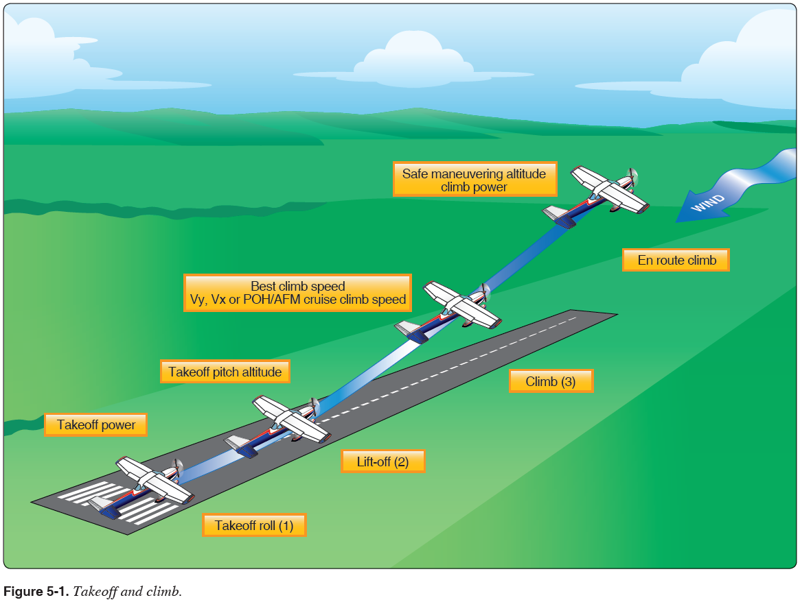
Cross Wind Takeoff & Climb

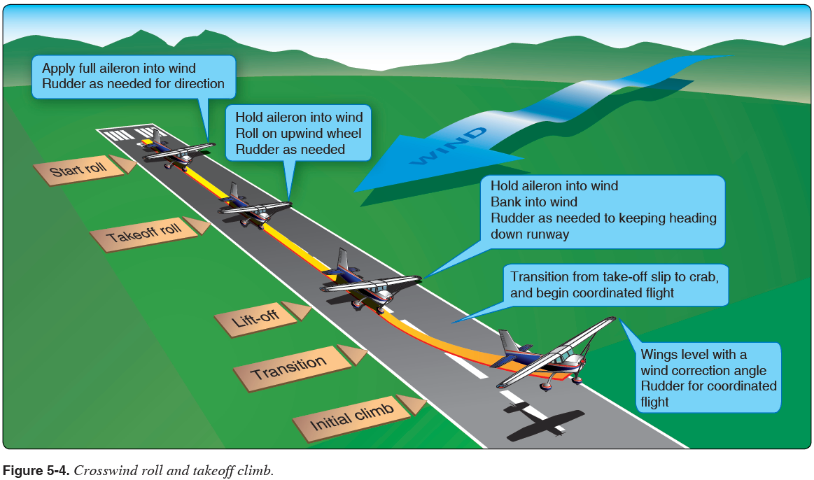
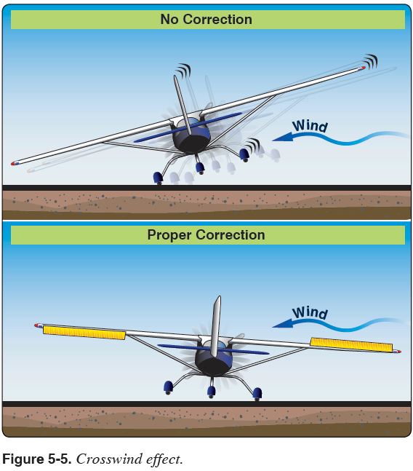
Short Field Takeoff & Max Performance Climb
Confirm runway length required to T/O and clear 50’ obstacle
Flaps = 10º
Check approach for traffic
Taxi onto runway, lineup on centerline at edge of threshold
Use proper control inputs for wind conditions
Verify runway # with heading indicator
Hold brakes
Smooth application of full throttle. Callout: Instruments in the green
Release brakes and accelerate
Callout: Airspeed alive
Rotate
Rotate at 55 kts
Climb at Vx - 62 kts until clear obstacle (POH specifies 56 kts)
Climb at Vy – 74kts
Flaps up > 60 kts, > 200’ (safe altitude)
500’ – climb power, climb at 80 kts

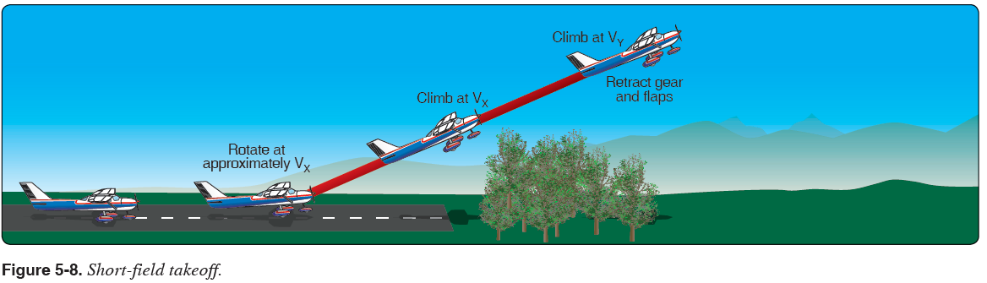

Soft Field Takeoff & Climb
Flaps = 10º
Check approach for traffic
Maintain full AFT stick position for taxi and initial takeoff roll
Taxi onto runway, lineup with centerline (do not stop, keep AC moving)
Use proper control inputs for wind conditions
Verify runway # with heading indicator
Smooth and continuous application of full throttle
Callout: Instruments in the green
Airspeed alive
Allow AC to accelerate in nose high attitude
Aircraft will lift off into ground effect
Lower angle of attack to accelerate in ground effect
Accelerate to 56 kts for obstacle or Vy if no obstacle
(Climb at 56 kts until clear of obstacle then at Vx)
Clear of obstacle or 200’ flaps up
Climb at Vy – 74kts
500’ – climb power, climb at 80 kts

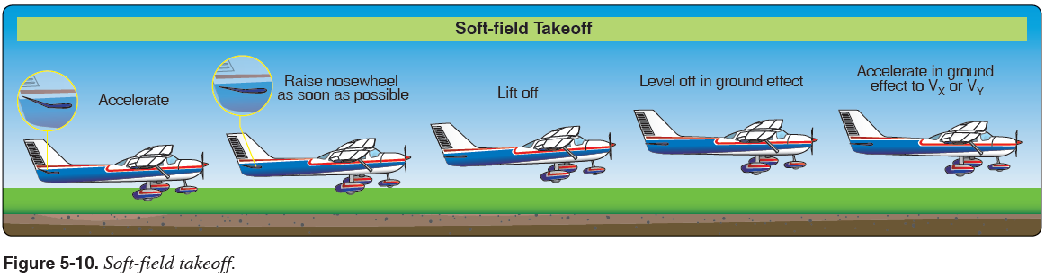

Normal & Crosswind Approach & Landing
5 Phases:
- Downwind 90 kts, reduce to 1700 rpm, flaps 10º, trim for 85 kts
- Base Leg flaps 20º, 75 kts
- Final Approach flaps 30º, 65 kts
- Round Out
- Touchdown
- After landing roll

Objective: To develop the student’s ability to safely and accurately land the airplane in a designated area.
Procedure:
- Fly the traffic pattern following the Traffic Pattern Operations procedure as above
- On the Final leg:
- Set the flaps to 30°.
- Adjust pitch and power to maintain the descent to touchdown point at 65 KIAS.
  - Add 1/2 gust factor as necessary.
- Once landing is assured, reduce power to idle and continue the flare to touchdown on the main tires within 200’ beyond a specified point.
- Hold the nose gear off of the runway with back-pressure.
- After the nose wheel has touched the ground, gently apply brakes while maintaining runway centerline.

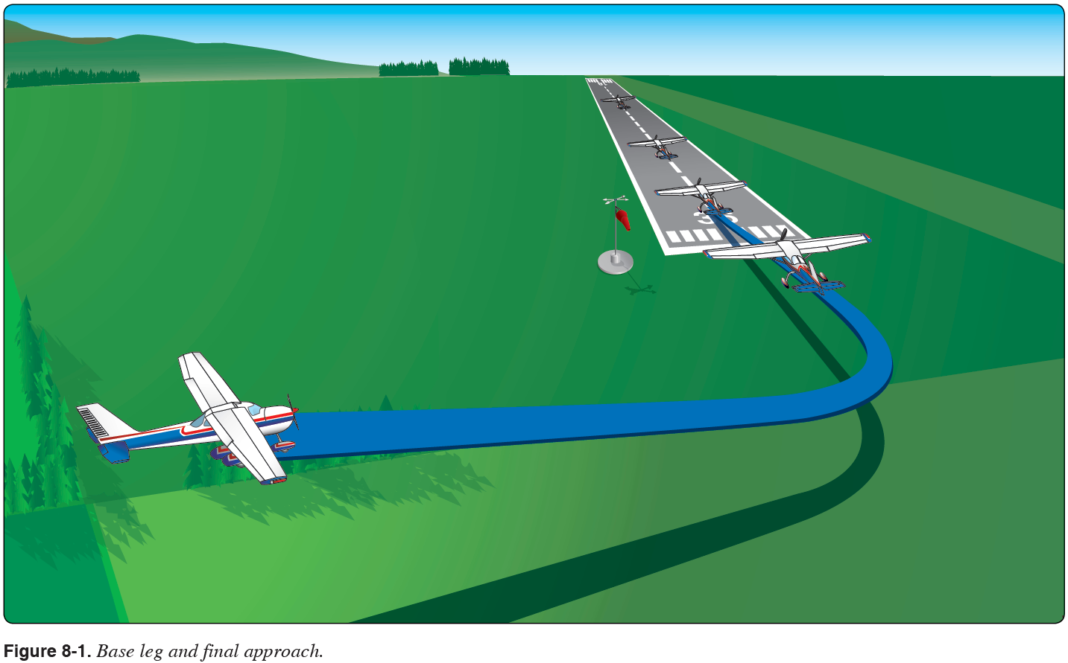
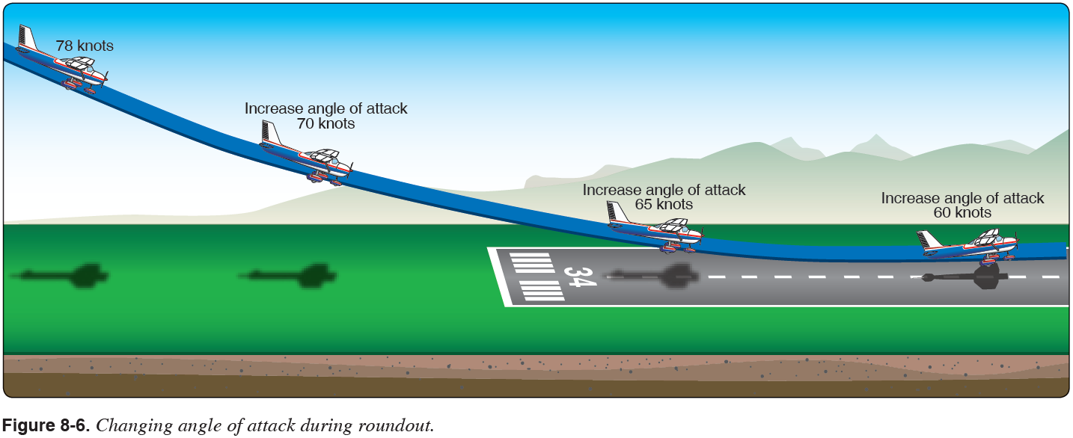

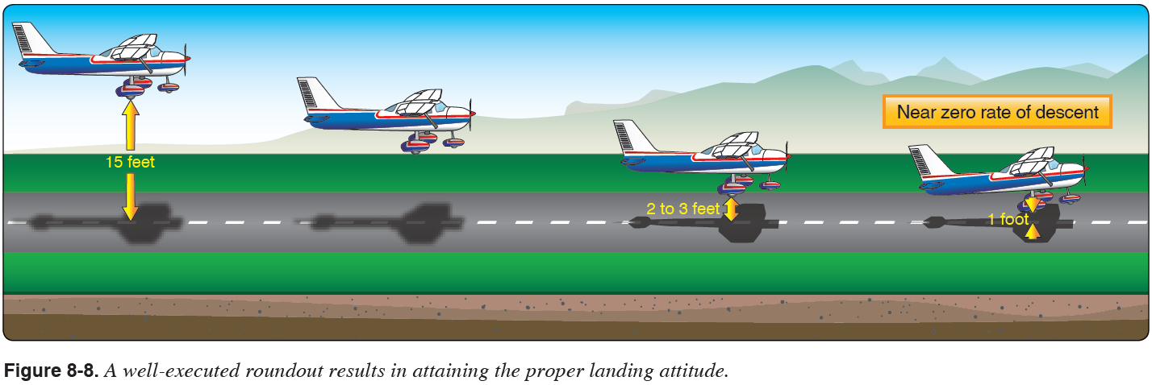
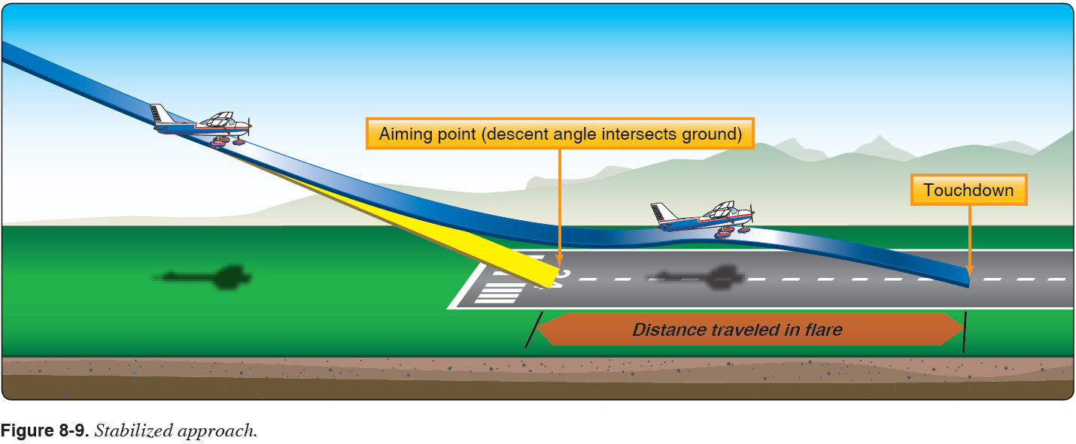
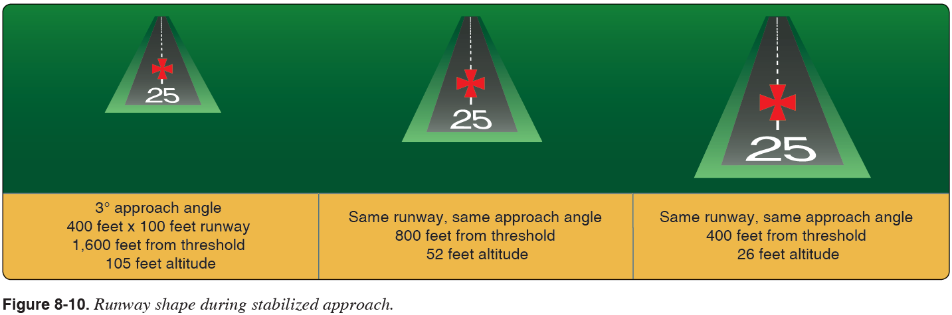
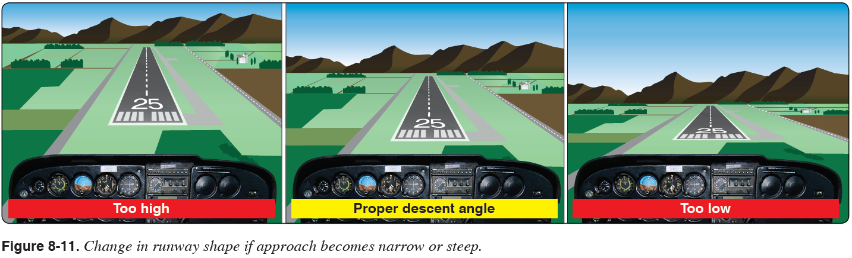
Crosswind Approach & Landing
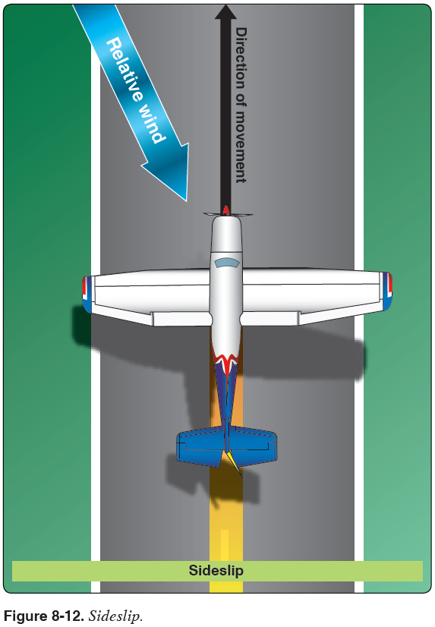
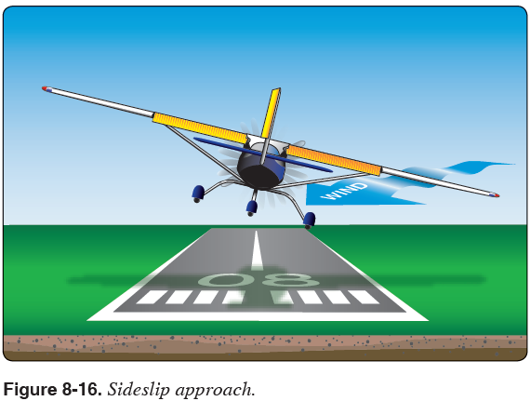
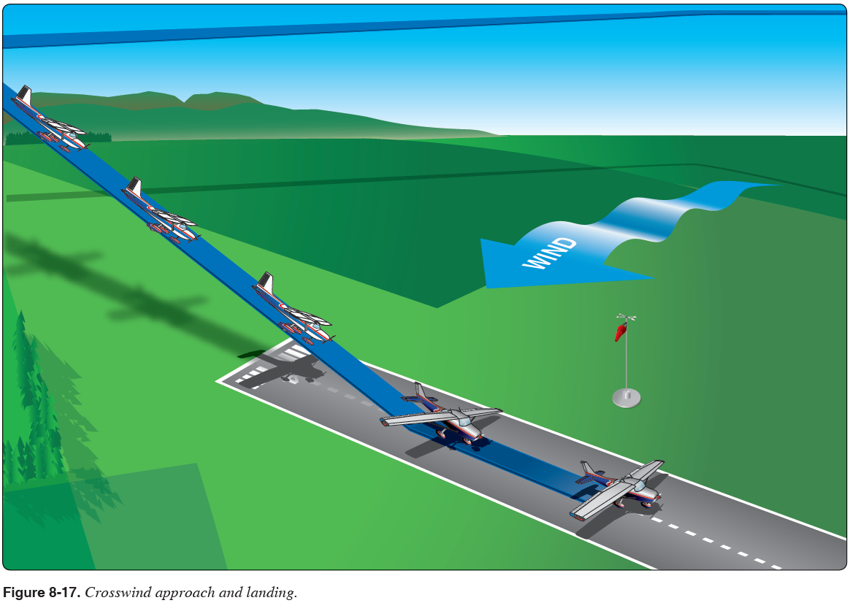

Forward Slip to Landing

Objective: To develop the student’s ability to dissipate altitude without increasing the airplane’s speed during a forward slip to landing.
Procedure:
- Fly the traffic pattern following the Traffic Pattern Operations as in the normal approach.
- Do not descend below 500’ AGL until the Final leg.
- On the Final leg:
- Reduce the throttle to idle.
- Note the wind direction.
- Smoothly apply full rudder in the opposite direction of the wind.
- Use opposite aileron to slip into the wind.
- Fly at an airspeed of 65 KIAS.
  - Add 1/2 gust factor as necessary.
- At the round out, align the airplane with the runway centerline by releasing rudder pressure and adjust the ailerons as necessary to keep the wings level.
- Flare to touch down on the main wheels first within 400’ beyond a specified point.
- After the nose wheel is down, gently apply brakes.
Note: Because of the location of the pitot tube and static port, the airspeed indicator may have a considerable degree of error.
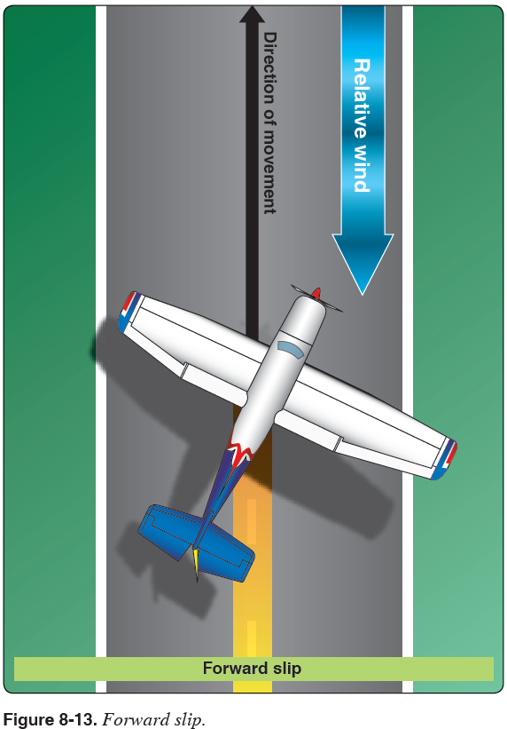
Go-Around / Rejected Landing

Objective: To develop the student’s ability to discontinue the approach and attempt another approach under more favorable conditions.
Procedure:
- Make decision to go-around
- Apply max power, adjust pitch for level flight
- Flaps to 20º
- Increase airspeed to 60 kts
- Climb at 62 kts,, flaps 10º
- Obstacles cleared & 65 kts, flaps up
- Pitch up to 7º for Vy – 74 kt climb

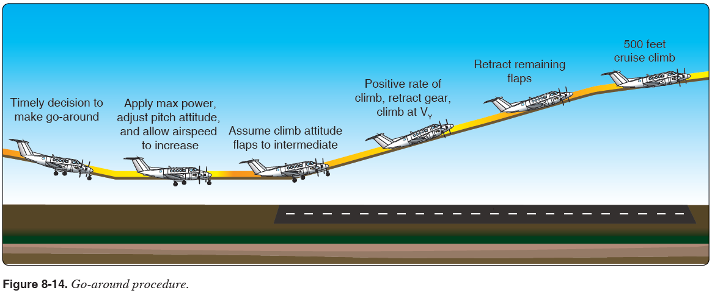

Short Field Approach & Landing

Objective: To develop the student’s ability to obtain maximum performance from the aircraft so that the landing may be consistently accomplished with precision in a short distance.

Procedure:
- Fly the traffic pattern following the Traffic Pattern Operations procedure as in normal approach.
- On the Final leg:
- Set the flaps to 30°.
- Adjust pitch and power to maintain the descent to touchdown point at 61 KIAS.
  - Add 1/2 gust factor as necessary.
- Maintain the predetermined aiming point with pitch and power corrections until approaching the round out.
- Once landing is assured, reduce power to idle and continue the flare to touchdown at the predetermined point with 100’ on the main tires first.
- In a controlled and deliberate manner, lower the nose gear to the runway.
- After the nose wheel has touched the ground, apply full back pressure with the yoke.
- Retract the flaps to zero and smoothly apply maximum braking without locking up the wheels while maintaining the aircraft on the runway centerline.
Note: This maneuver is NOT complete until the aircraft has come to a COMPLETE stop.
Note: Approach speed should be increased as required (typically 5 to 15 KIAS) if turbulence or wind shear conditions exist.

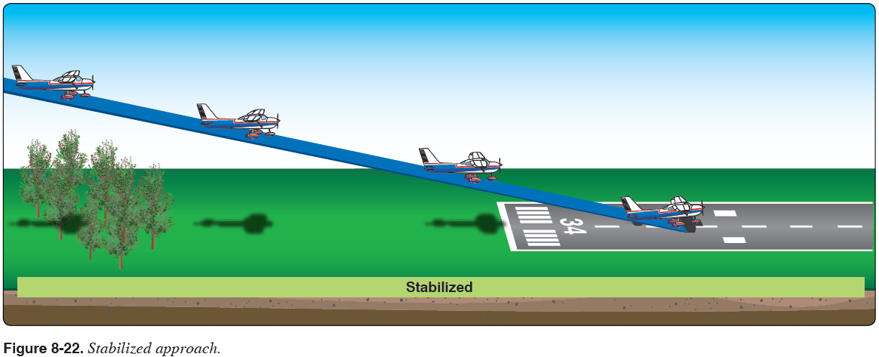
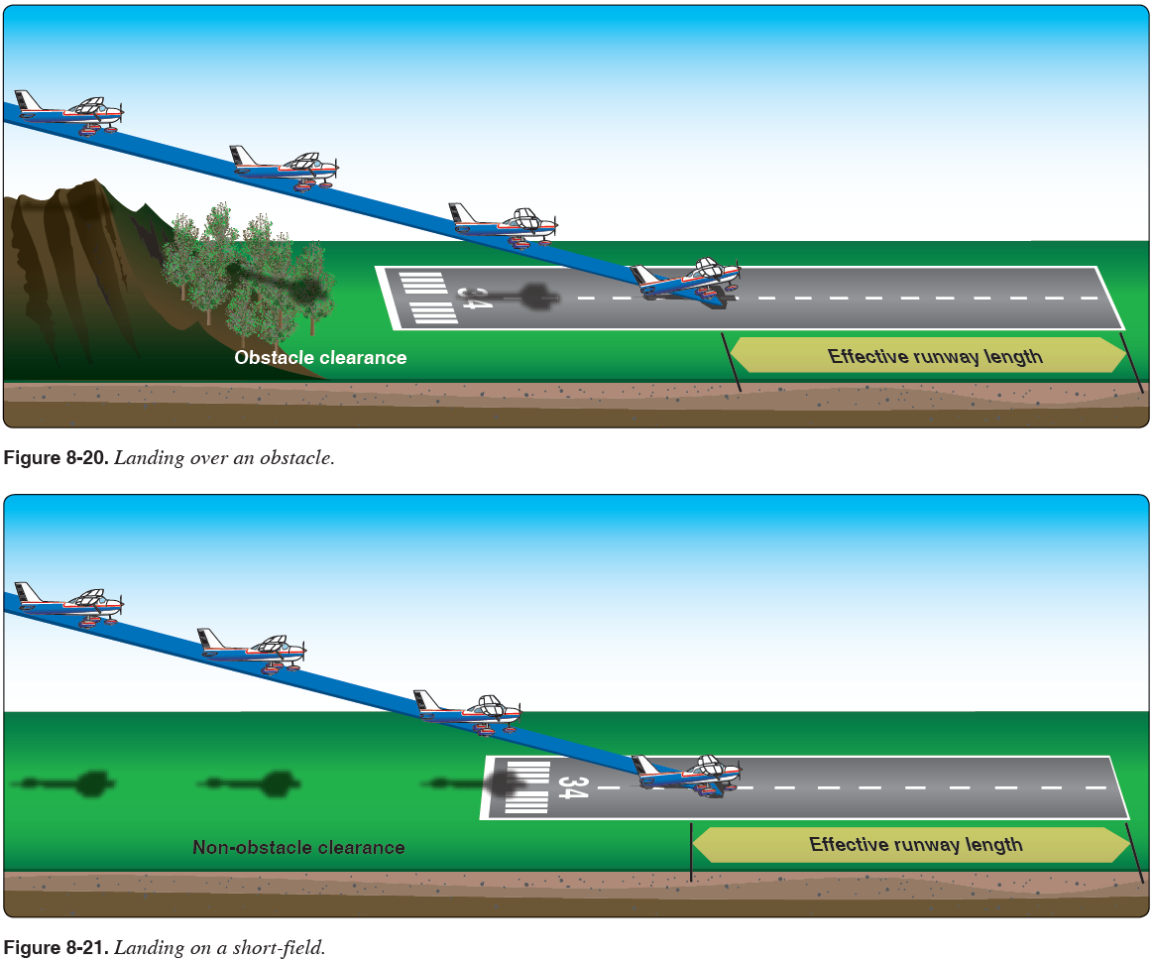

Soft Field Approach & Landing

Objective: To develop the student’s ability to obtain maximum performance from the aircraft so that a soft touchdown at the slowest possible airspeed can be accomplished.

Procedure:
- Fly the traffic pattern following the Traffic Pattern Operations procedure as in the normal approach.
- On the Final leg:
- Set the flaps to 30°.
- Adjust pitch and power to maintain the descent to touchdown point at 65 KIAS.
  - Add 1/2 gust factor as necessary.
- During the round out add a slight amount of power to prolong flight in ground effect.
- Slowly reduce power and allow the aircraft to settle onto the runway on the main wheels
- Close the throttle during the roll out while holding the nose off the runway with back pressure
- Flaps should remain extended until clear of the runway.
- After the nose wheel has touched the ground, maintain the runway centerline and DO NOT apply brakes.
- Keep the aircraft moving and maintain elevator back pressure while taxiing on a soft surface.

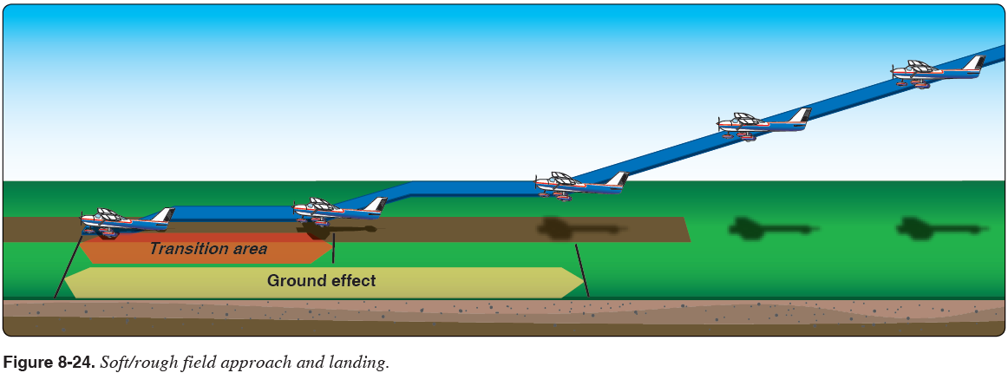

Power-Off 180º Accuracy Approach & Landing

Objective: To teach the student to develop judgement in estimating distances and glide ratios to accurately touchdown on a previously chosen point on the runway.
Procedure:
- Fly the traffic pattern following the Traffic Pattern Operations procedure as in the normal approach.
- When the aircraft is abeam the point of intended landing, reduce the throttle to idle and maintain altitude until reaching best glide speed of 68 kts.
- Use the flaps as necessary to maintain desired descent gradient.
- At the round out, continue the flare to touchdown on the main tires first.
- Touch down within 200’ beyond a specified point.
- In a controlled and deliberate manner, lower the nose gear to the runway.
- Retract the flaps to zero.
- After the nose wheel has touched the ground, gently apply brakes while maintaining runway centerline.

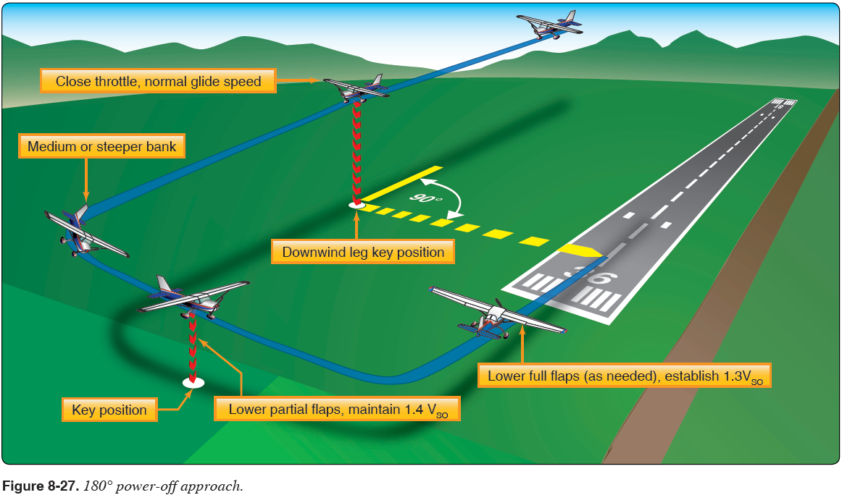

Emergency Approach & Landing
- Emergency Approach and Landing simulates an emergency situation where an aircraft is required to descend as rapidly as possible to a forced landing with little or no power (engine failure) available
- Additionally, Emergency Approach and Landing improve pilot technique for power off turns, wind drift control, planning, orientation, and division of attention

Procedure:
- Clearing Turns (left then right), Call intensions 123.5
- Power to idle. Flaps up. Establish best glide attitude for 68 KIAS
- Trim to maintain airspeed
- Determine the wind direction
- Select a reference point that is near an area where an emergency landing can be made
- Fields are best, roads may contain powerlines
- Look for flat, low populated, low obstruction areas
- Turn the aircraft toward the landing site
- Complete the engine failure during flight checklist:
- If engine restart is unsuccessful, plan and fly a pattern
- Establish a high-key point at 1,000' AGL downwind and abeam to the touchdown point
- Establish a low-key point at 500' AGL on base before the turn to final
- Maneuver as necessary to reach the high-key point
- Not to exceed 60°
- Clear the engine on the upwind legs every turn
- Operating the engine at idle speed for prolonged periods may result in excessive engine cooling or spark plug fouling
- Check engine operation during the glide by "clearing" the engine on every upwind or every 1,000' AGL (to minimize any variation in ground-speed and turn radius) as appropriate

NOTE:
When spiraling, the bank angle can be adjusted to vary altitude loss so as to arrive at the high key point at the appropriate altitude. The Cessna 172S loses approx. 800 -1000' in a 20° bank - 360° turn; and approximately 400 - 500' in a 45° bank - 360° turn. If altitude does not permit the use of a high-key point, proceed to a low key point

- Turn onto the base leg to be able to conserve or dissipate altitude to reach the desired landing point
- At low-key position, set flaps to 10° if desired
- Turn final to align with the landing site and, when the landing is assured, set the flaps to 30° if desired
- Complete the engine failure – FIELD MADE checklist to secure the engine
- Touchdown slightly tail low and apply brakes as required
- Fly slightly high with options to slip than too low with no options

NOTE:
Unless the approach is made to an airport runway, the simulated emergency approach and landing should be terminated as soon as it can be determined that a safe landing could have been made, or 500' AGL, whichever occurs first.

- Complete the cruise checklist

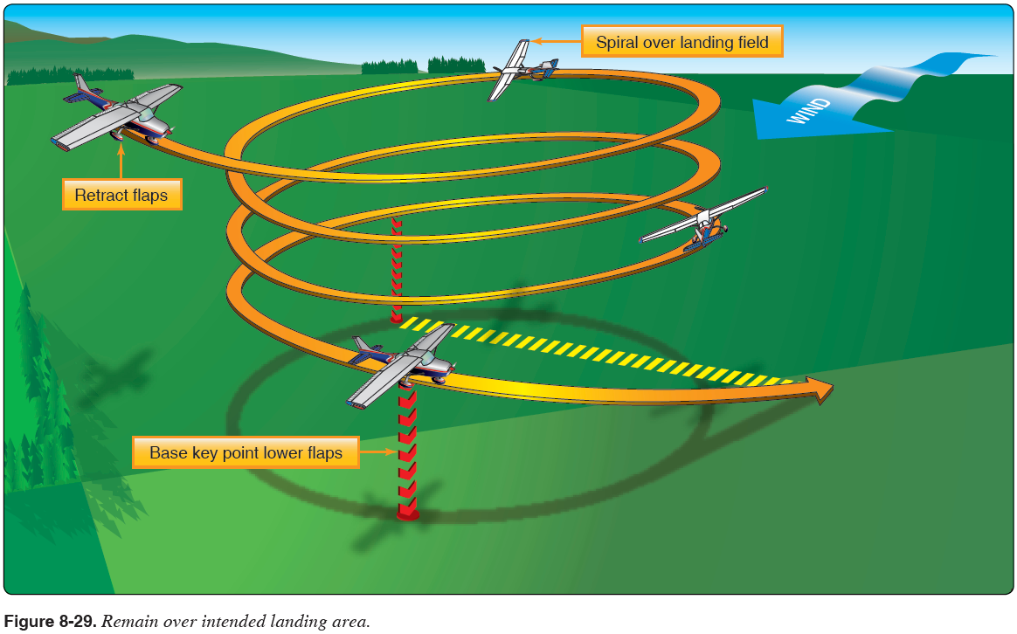

Common Errors:
- Improper airspeed control
- Poor judgement in the selection of an emergency landing area
- Failure to estimate the approximate wind speed and direction
- Failure to fly the most suitable pattern for the existing situation
- Failure to accomplish the emergency checklist
- Undershooting or overshooting the selected emergency landing area

Maneuvering during Slow Flight

3000’ (above 1500’ AGL )
Clearing Turns (left then right), Call intensions 123.5
GUMPSCC
Confirm Airspeed, Altitude, Heading
Power 1500 rpm
Below 110 kts, flaps 10º
Decelerate, below 85 kts, flaps down to 30º
Establish slow flight attitude – nose high without stall warning horn (50 kts)
Add power as required to maintain altitude and attitude (airspeed)

Recovery Full Power
Lower nose to maintain altitude
As airspeed increases, raise flaps
Pitch, power, trim for cruise flight
Perform Cruise Checklist

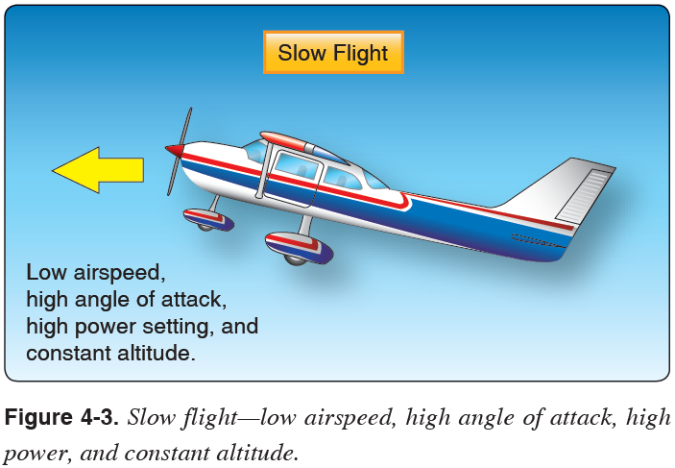

Power On Stalls

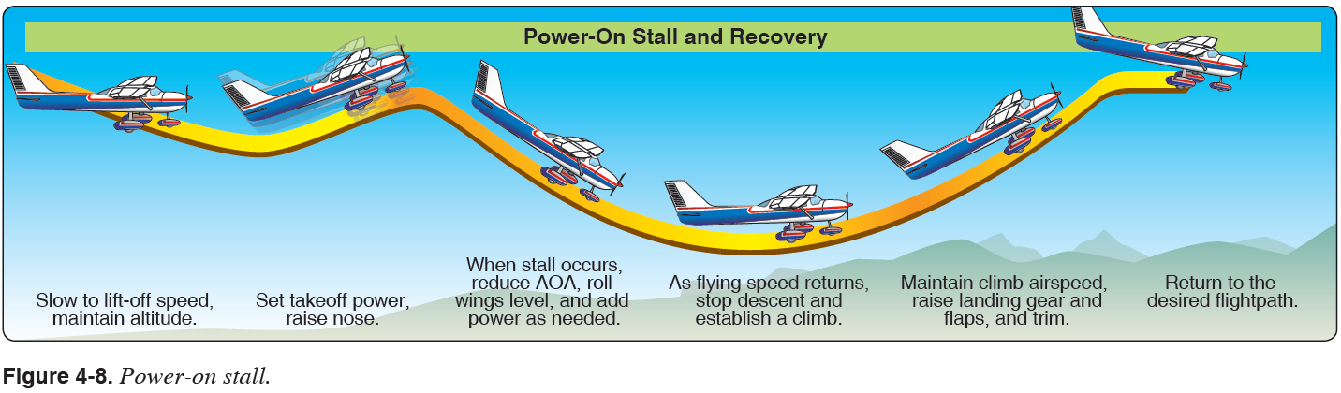
Power Off Stalls

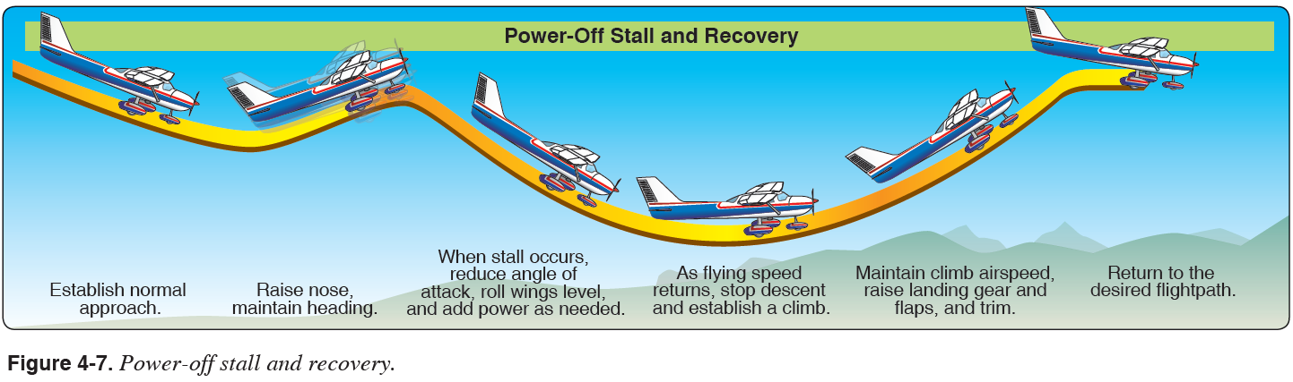

Cross-controlled Stall

Elevator Trim Stall

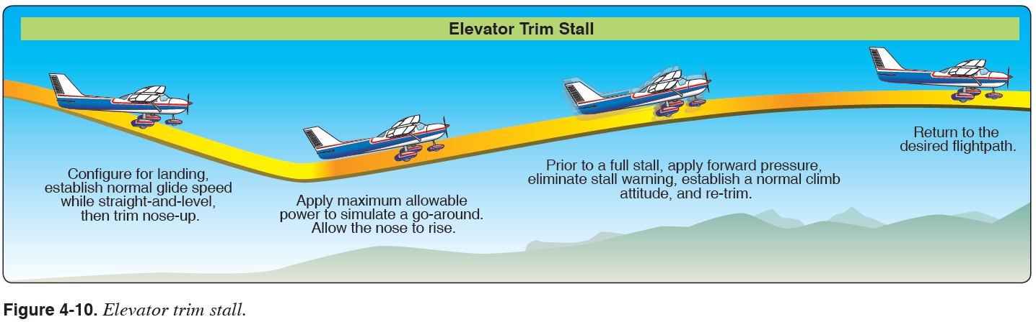
Secondary Stall

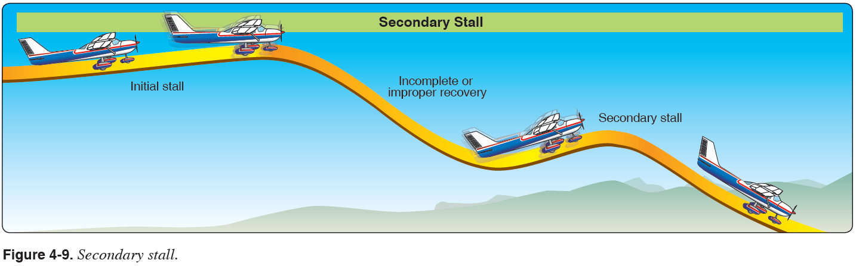
Accelerated Maneuver Stall

Objective: To demonstrate to the student that a stall is a function of angle of attack & load factor, rather than airspeed.
Procedure:
- Perform this maneuver so that the recovery takes place at or above 3000’ AGL.
- Clearing Turns (left then right), Call intensions 123.5
- Reduce power to 1500 RPM and reduce airspeed.
- At 68 KIAS (20 KIAS above Vs):
- Adjust pitch to maintain altitude.
- Establish 45° of bank.
- Smoothly increase back pressure until the impending stall is reached.
- At the first indication of impending stall ( horn &/or buffet):
- Verbally announce the onset of the stall.
- Lower the pitch attitude slightly below a level pitch attitude.
- Use coordinated control inputs to maintain directional control and level the wings.
- Add full power.
- Adjust the pitch to an attitude that allows a positive rate of climb and an increase in airspeed to V_{y}.
- Upon reaching the specified recovery altitude, trim the aircraft for cruise.
Note: Never perform this maneuver with flaps extended.

The increased back pressure increased AOA, which increases the lift and thus the G load.

The increased G load increases the stall speed. The increase lift will also increase drag resulting in a decrease of airspeed.

For 172 S, stall speed 0º angle of bank, clean = 48 kts / stall speed 45º angle of bank, clean = 57 kts

Steep Turns - Develops smoothness, coordination (ball centered), orientation, & aircraft control
- Uses a bank angle steep enough to cause an overbanking tendency.
A/C max G load = 3.8 G’s, 60º bank LF = 2 G’s, 70º bank LF = 2.8 G’s, 78º bank LF = 3.8 G’s
Stall Speed: at 60º bank stall speed increases by 40%, from 48 kts to 67 kts

Steep turns will expose the pilot to:
- higher load factors
- airplanes inherent overbanking tendency past 30º of bank
- loss of vertical component of lift when the wings are steeply banked
- need for substantial pitch control pressures
- need for additional power to maintain altitude and airspeed

- 2,000’ msl (min 1500’ AGL)
- Clearing Turns (left then right). Call intensions 123.5
- Confirm Airspeed, Altitude, reference heading
- Power 2250 rpm, 95 kts
Keep your eyes outside for situational awareness - Use section lines and prominent landmarks
- Establish attitude for steep turn, 50º bank.
- Thru 30º of bank:
- Increase pitch due to decrease vertical lift vector
- Add 100 rpm (power) to overcome induced drag and maintain airspeed
(Trim 2 to 2 ½ turns of trim wheel if desired)
- Add power as required to overcome induced drag and maintain airspeed
- Watch for reference heading and lead rollout by 17º (1/3 of the bank angle)
- Repeat 360º turn in other direction

(Altitude +/- 100’, Airspeed +/- 10 kts, Bank +/- 5º, roll out on entry heading +/- 10º
Discussion: Load factor, Angle of bank limitations, effect on stall speed, power required, overbanking tendency

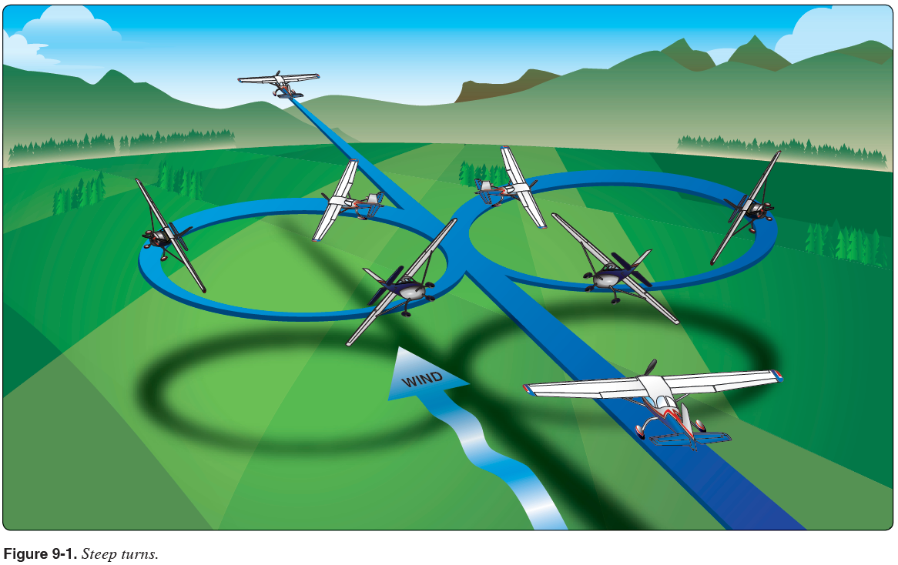

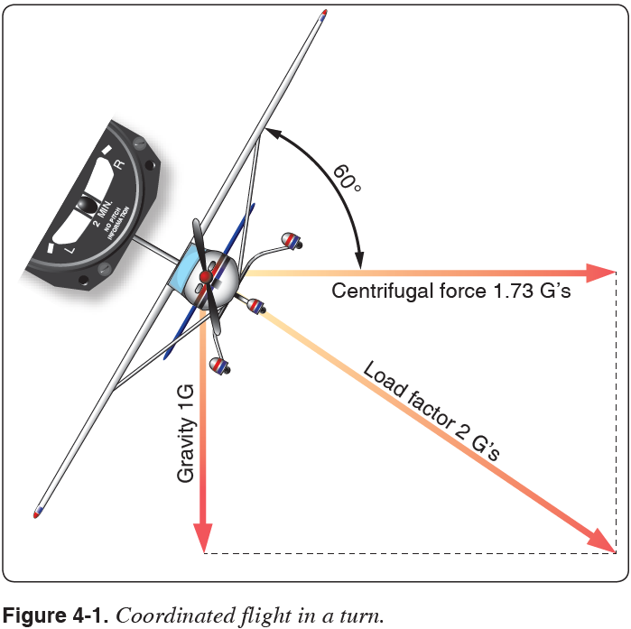

Common Errors
- Not clearing the area
- Inadequate pitch control on entry or rollout
- Gaining altitude or losing altitude
- Failure to maintain constant bank angle
- Poor flight control coordination
- Ineffective use of trim
- Ineffective use of power
- Inadequate airspeed control
- Becoming disoriented
- Performing by reference to the flight instruments rather than visual references
- Failure to scan for other traffic during the maneuver
- Attempts to start recovery prematurely
- Failure to stop the turn on designated heading

Steep Spiral

Objective: Develops skill with Power-off turns, wind drift control, planning, coordination, orientation, & division of attention.
Procedure:
- Start at 4000’ to allow 3 complete turns before 1,500’ AGL
- Establish best glide speed of 68 kts
- Pick a suitable ground reference point
- Establish spiral downwind with a 50º -55º bank at 68 kts. (steepest bank)
- Clear engine each time you turn into the wind.
- Use steep and shallow banks as drift requires
- Stay coordinated, vary back pressure with bank angle as required to maintain airspeed

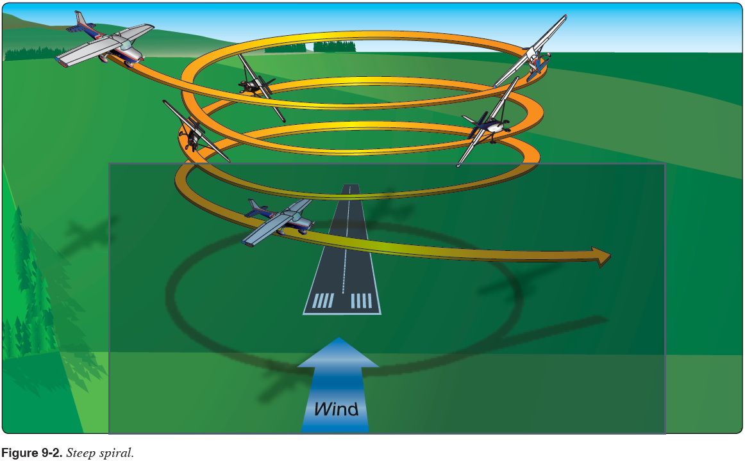
Common Errors
- Not clearing the area
- Inadequate pitch control on entry or rollout
- Gaining altitude
- Not correcting the bank angle to compensate for the wind
- Poor flight control coordination
- Ineffective use of trim
- Inadequate airspeed control
- Becoming disoriented
- Performing by reference to the flight instruments rather than visual references
- Not scanning for other traffic during the maneuver
- Not completing the turn on designated heading or reference
Chandelle
A maximum performance climbing 180º turn developing the pilot’s orientation and flying skills (coordinated flight)

2,000’ AGL (min 1500’ AGL)
Clearing Turns (left then right), Call intensions 123.5
Confirm Va Airspeed, Altitude, and outside references
Power 2350 rpm, 105 kts, clean configuration
Keep your eyes outside for situational awareness
- Use section lines and prominent landmarks for orientation

Establish 30º bank, increase pitch, full power

0 - 90º ..... constant 30º of bank, increasing pitch to max pitch attitude (~17º up), A/S slowing
Increasing need for right rudder as a/c slows

90º - 180º ….. constant pitch, decreasing bank, wings level at 180º, slowest airspeed (50-55 kts)
Continued need for additional right rudder
Recovery:
- to level cruise flight with minimum loss of altitude
- perform cruise checklist

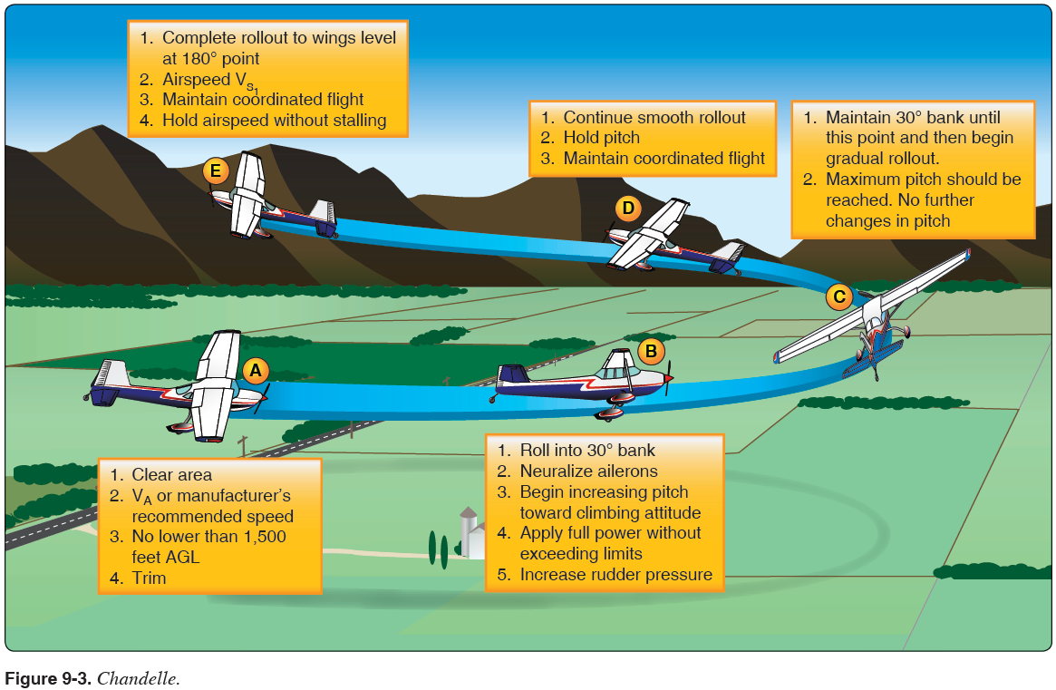

Common Errors
- Not clearing the area
- Initial bank is too shallow resulting in a stall
- Initial bank is too steep resulting in failure to gain maximum performance
- Allowing the bank angle to increase after initial establishment
- Not starting the recovery at the 90º point in the turn
- Allowing the pitch attitude to increase as the bank is rolled out during the second 90º of turn
- Leveling the wings prior to the 180º point being reached
- Pitch attitude is low on recovery resulting in airspeed well above stall speed
- Application of flight control pressures is not smooth
- Poor flight control coordination
- Stalling at any point during the maneuver
- Execution of a steep turn instead of a climbing maneuver
- Not scanning for other traffic during the maneuver
- Performing by reference to the flight instruments rather than visual references

Lazy 8’s
A combination of alternating (R&L) climbing & descending 180º turns developing the pilot’s orientation and flying skills (coordinated flight)

3,000’ (ACS = min 1500’ AGL)
Clearing Turns (left then right), Call intensions 123.5
Confirm Va airspeed, altitude, and outside 45°, 90°, and 135° reference points
Power 2350 rpm, 105 kts
Keep your eyes outside for situational awareness - Use section lines and prominent landmarks for orientation
Begin pitch and lazy bank simultaneously

0 - 45º ..... 15º of bank, highest pitch attitude (~17º up), slowing airspeed
( start with very slow roll and increase pitch, more right rudder as a/c slows )
45º - 90º ….. 30º of bank, pitch attitude dropping thru horizon, slowest airspeed (53-58 kts)
(Cross control may be required to not exceed 30º of bank)
90º - 135º ..... 15º of bank, lowest pitch attitude (~12º dwn), increasing airspeed
( decrease right rudder as a/c speed increases )
135º - 180º ….. 0º of bank, level pitch attitude, entry airspeed, entry altitude, entry heading

Verbalize airspeed, altitude, and outside reference heading
(Altitude +/- 100’, Airspeed +/- 10 kts, roll out on entry heading +/- 10º

Immediately begin turn in opposite direction, repeat same steps in this new direction

Symmetry Checks Input Changes
Points 0º & 180º - airspeeds & altitudes are equal - Pitch, roll & yaw inputs continuously vary throughout the Lazy 8
45ºL & 45ºR - altitudes are equal - Orientation & coordination are paramount skills to develop
90ºL & 90ºR - altitudes are equal - Coordinated flight is primary goal
135ºL & 135ºR - altitudes are equal

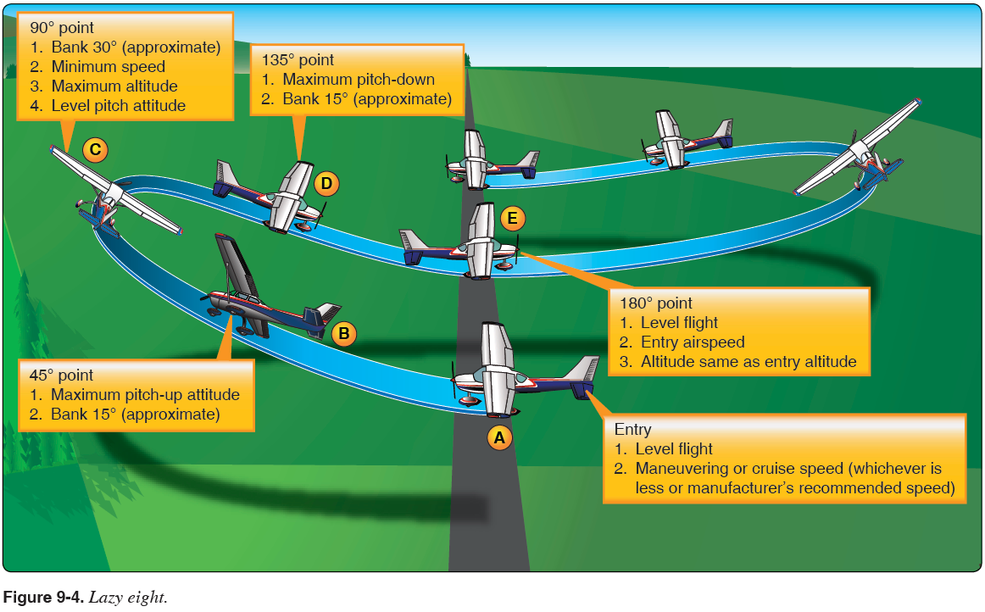

Lazy Eights Procedure:

- Becoming disoriented Perform clearing turns
- Adjust the pitch and power to maintain altitude and set V_{a} power
  - Trim as necessary
- Pick 45°, 90°, and 135° reference points on or out to the horizon
  - The farther away, the more accurate and steady they will be
- From straight and level flight, initiate a climbing turn (simultaneously increase bank and pitch slowly) in the direction of the 45° reference point
  - Slowly increase bank and pitch so that at the 45° point the airplane is passing through 15° of bank and maximum pitch up (around 10°)
  - If bank is too fast, the aircraft will increase the rate of turn too quickly and reach 45° point before highest pitch is attained
- At the 45° reference point the maximum pitch up (highest) altitude should be achieved with a 15° bank angle continuing to increase to 30°
- From the 45° reference point, while allowing the bank angle to continue increasing, allow the pitch to decrease so that at the 90° reference point the maximum bank angle (30°) is achieved and the pitch attitude is passing through level flight at minimum airspeed (5-10 knots above V_{S} )
  - Right rudder pressure will have to be applied to counteract torque
  - More right rudder is required during the climbing turn to the right than in the turn to the left
  - Record altitude gain at the 90° point
- From the 90° reference point, allow the pitch attitude to continue decreasing and initiate a slow decrease in the bank angle, continuing a descending turn in the direction of the 135° reference point
  - Continue to decrease pitch and slowly decrease bank so that at the 135° point, the airplane is passing through 15° of bank and maximum pitch down (7° nose down)
- At the 135° reference point, the maximum pitch down (lowest) attitude should be achieved with a 15° bank angle continuing to decrease to 0°
- From the 135° reference point, continue decreasing the bank angle while allowing the pitch to increase so that the airplane returns to the entry airspeed and altitude by the 180° reference point
  - The airspeed should not exceed the entry airspeed during the turn from the 90° reference point to the 180° reference point
- From the 180° point, immediately commence a climbing turn in the opposite direction, repeating the steps above
- Upon completion of the maneuver, resume normal cruise
  - Re-trim as necessary
- Complete cruise flow/checklist

Common Errors:
- Not clearing the area
- Inadequate pitch control on entry or rollout
- Gaining or losing altitude
- Failure to maintain constant bank angle
- Poor flight control coordination
- Ineffective use of trim
- Ineffective use of power
- Inadequate airspeed control
- Becoming disoriented
- Performing by reference to the flight instruments rather than visual references
- Failure to scan for other traffic during the maneuver
- Attempts to start recovery prematurely
- Failure to stop the turn on designated heading

Eight’s on Pylons

Objective: To teach the student to maneuver an aircraft at a pivotal altitude
around ground reference points while maintaining division of attention,
coordination, and smooth control inputs.
Procedure:
- 3,000’ (min 1500’ AGL)
- Clearing Turns (left then right), Call intensions 123.5
- Confirm Va airspeed, altitude, and outside references
- Power 2300 rpm, 100 kts
Keep your eyes outside for situational awareness - Use section lines and prominent landmarks for orientation
- Perform this maneuver at or below maneuvering speed.
- Determine the wind direction.
- Select two reference points perpendicular to the wind direction from which an emergency landing can be made should the need arise.
- Determine the pivotal altitude by squaring the ground speed and dividing the result by 11.3.
8. Enter the maneuver 45° to the downwind.
9. Once abeam the pylon, begin the turn.
a. The steepest bank angle should not exceed 40°.
- Vary altitude to maintain the reference line on the pylon.
a. Pylon forward - pitch down and reduce bank angle.
b. Pylon rearward - pitch up and increase bank angle.
- Plan rollout from 1st pylon to allow for a 45° entry & 3-5 seconds of level flight to the next pylon
12. Once abeam the second pylon, begin to turn in the opposite direction.
13. After completing the turn around the second pylon, depart the maneuver on the entry heading.
14. After the maneuver is complete, trim the aircraft for cruise.

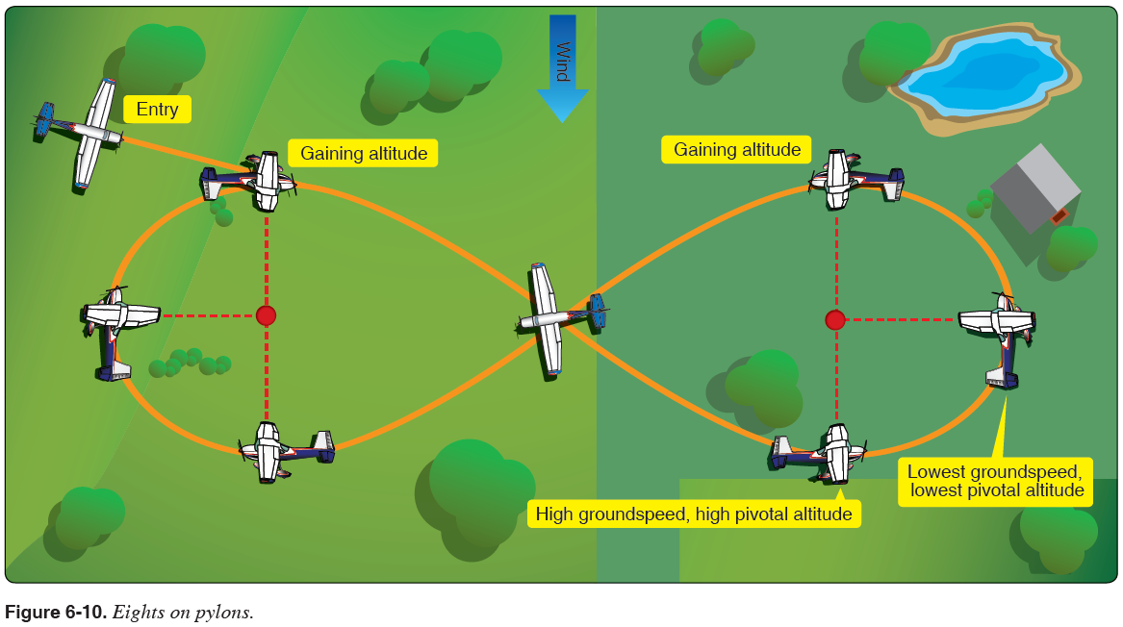
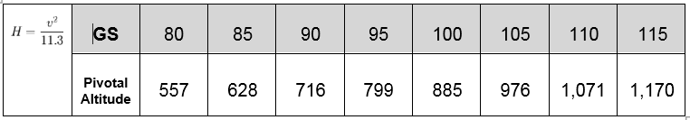

Common Errors
- Attempting to hold a pylon with incorrect use of rudder
- Failure to adequately clear the area above, below, and on either side of the airplane for safety hazards, initially and throughout the maneuver.
- Poor selection of ground references.
- Failure to establish a constant, level altitude prior to entering the maneuver.
- Failure to maintain adequate altitude control during the maneuver.
- Failure to properly asses wind direction.
- Failure to properly execute constant radius turns.
- Failure to manipulate the flight controls in a smooth and continuous manner.
- Failure to establish the appropriate wind correction angles.
- Failure to apply coordinated aileron and rudder pressure, resulting in slips or skids.
- Failure to maintain orientation as the maneuver progresses.

Rectangular Course

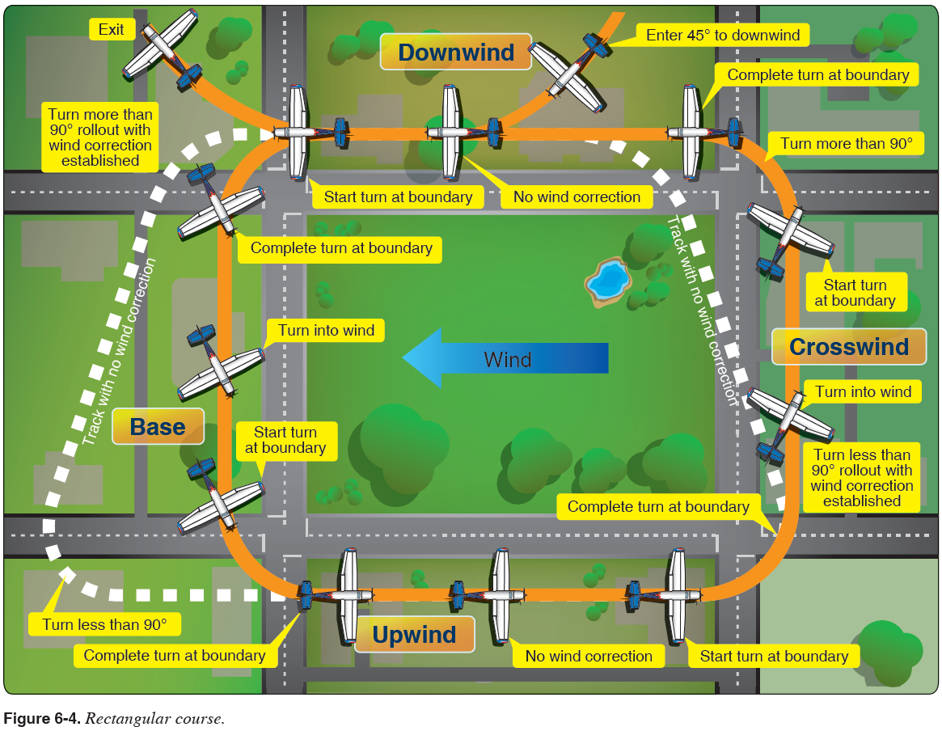

S Turns Across a Road

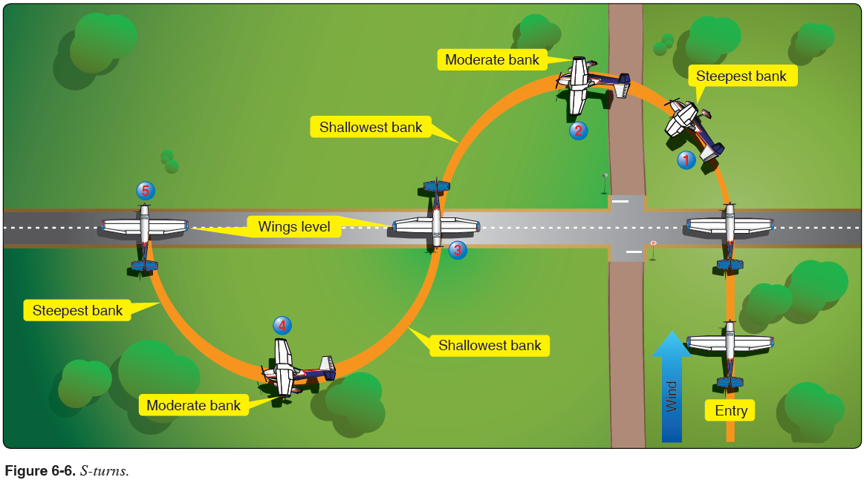

Turns Around a Point

